
Spring 2026 Business Analytics Capstone
(BUSA-521-01W)

Final Project Report:

A Predictive Analytics Framework for Forecasting Corporate Performance Using XBRL Data

GROUP 4
Seth Reyes
Adetoro Soyemi
William Adams
Amara Uazim
Samiha Tanjeem

Kaggle Dataset: US Stocks Fundamentals (XBRL)

Executive Summary
Kaggle’s post titled “US Stocks Fundamentals (XBRL)” covers fundamental data for 12,129 companies based on XBRL. This project examines if financial indicators derived from XBRL data can be used to predict a company’s next-year return on assets. The XBRL study uses financial statement information for publicly traded companies in the US. After cleaning and restructuring the data, our final analysis included 279 observations across 182 companies from 2011 to 2013.
Given our large dataset, we collectively focused on identifying which current year financial ratios are most useful for forecasting future performance. Our main predictors of course included return on assets but also profit margin, debt ratio, asset turnover, accounts receivable growth, inventory growth, and depreciation to assets. A pooled OLS regression model was used in R, along with diagnostic testing for multicollinearity, heteroskedasticity, and autocorrelation. We implemented robust standard errors to address heteroskedasticity further.
Our project results show that the current return on assets is the strongest and most consistent predictor of return on assets a company is expected to receive next year. This supports the idea that profitability tends to persist over time. Debt ratio was also a very significant and negative which shows that higher leverage is associated with weaker future performance. Profit margin was statistically significant but unexpectedly negative in the full model, while asset turnover, accounts receivable growth, inventory growth, and depreciation to assets were not significant overall.
The firm size analysis showed that predictive factors differed significantly across small, medium, and large firms. Although the full regression model did not outperform the baseline model in out of sample accuracy, it still provided useful interpretive value by identifying the financial factors most closely connected to future return on assets.

1. Introduction

1.1 Background Problem
Many businesses and investors struggle to predict the profitability of a company's future financial performance in a scalable way. This is important because it supports budgeting, capital allocation, and risk management decisions to keep organizational performance consistent. The traditional predictive measures of cash flow forecasting requires manual firm by firm data collection, and expensive data subscriptions which is very difficult to perform across a large number of companies. It is also extremely time consuming for the financial analysts.
The US stock companies submit their financial data to the US Securities and Exchange Commission in a format called XBRL or eXtensible Business Reporting Language (2025). This makes the data available to the public but it is not easy to use right away since it requires a lot of data cleaning and adjustments done through technical tools before analysis. Sometimes the raw XBRL data contains financial metrics that are not defined across companies, which makes comparing financial performances more challenging. This project uses the US Stocks Fundamentals dataset with financial data of 12,129 companies to solve this problem. Our team will clean the data, calculate key financial ratios, and use regression analysis to quantify which financial indicators can best predict a company’s next year ROA.

1.2 Objectives
Our listed objectives go as follows:
- Build a firm-year dataset from XBRL indicators.
- Engineer ratios
- Use regression models to predict future performance
- Summarize drivers for decision-making
This project will construct a firm-year panel dataset using XBRL financial indicators by transforming raw data into a structured firm-year format. Key financial statement variables including total assets, revenues, net income, liabilities, and stockholders’ equity will be extracted for each firm-year observation.
From these variables, we will engineer financial ratios to capture firm performance and financial structure. These ratios will include ROA, ROE, debt ratio, inventory growth, asset turnover, and profit margin. The dataset will also include a forward-looking variable, next-period ROA, which will serve as the primary outcome of interest.
We will estimate an OLS regression model in which next-period ROA will serve as the dependent variable, and current-period financial ratios (ROA, inventory growth, debt Ratio, asset turnover, and profit margin) will serve as the independent variables. This model will be used to examine the extent to which current financial performance and firm characteristics are associated with future profitability.
We expect current profitability to be positively associated with next-period performance, reflecting persistence in firm outcomes. We also anticipate that debt Ratio, inventory growth, asset turnover, and profit margin will be systematically associated with future ROA, although the direction and magnitude of these relationships will be determined empirically.
Overall, this project will aim to identify key financial factors associated with future firm performance using a structured, data-driven regression framework. Highlighting the importance of operational efficiency.

1.3 Research questions
Primary Research Question | - Which financial indicators are most useful for predicting a company's next year Return On Asset (ROA)?
Secondary Research Question | - Does the industry type or firm size influence the predictive factors of financial performance among the US stock firms?  - How much better does a regression model perform compared to a simple baseline as a prediction tool?

1.4 Potential contributions
The key contribution of our group project is identifying which financial indicators effectively predict a company’s next-year operating cash flow or net income. This will be done by evaluating accounting based measures, like profitability, inventory growth, debt ratio, liquidity, and efficiency indicators, to determine which variables provide the strongest and most reliable signal of near term financial performance. The results are intended to help decision-makers focus on the most informative drivers when assessing firm health, budgeting, and performance management.
The analysis will also test whether predictive relationships differ by industry and firm size, helping determine whether a “one size fits all” set of indicators is realistic or whether forecasting drivers are context-dependent across different types of firms. In addition, the project will emphasize interpretability by connecting model results back to financial meaning, not just overall prediction accuracy. Finally, our project will benchmark a regression model against a simple baseline forecast to quantify how much improvement is achieved, providing a clear standard for whether advanced modeling is practically worthwhile in a business setting.

2. Theoretical Background / Framework
Predictive analytics research supports using regression models to forecast business outcomes from historical quantitative indicators, with value judged by out-of-sample accuracy and interpretability for stakeholders. In this project, financial statement ratios/indicators will serve as standardized performance measures, and we will also account for time effects such as trends and quarterly seasonality when modeling next-period ROA.

2.1 Accrual Accounting Theory
Research consistently shows that accrual components play an important role in predicting future cash flows. Barth, Cram, and Nelson (2001) used Compustat data from 1987–1996 and found that total accruals were too broad to capture meaningful predictive information. When they separated accruals into specific components - such as accounts receivable, accounts payable, depreciation, amortization, and other accruals - the accuracy of forecasting future cash flows improved significantly. Breaking accruals into individual pieces allows regression models to identify which components increase future cash flow, which reduce it, and which add little information. This supports the idea that treating earnings or total accruals as one number hides important signals.
Casey and Ruch (2024) reinforced this direction using an apples-to-apples comparison. They showed that disaggregated earnings predicted future cash flow better than aggregate earnings and that certain items, like depreciation and non-operating income, reduced next-period cash flow. They also found that interest expense and income tax expense had very low statistical value in predicting next-year cash flow. Their results aligned with earlier findings and emphasized that detailed accrual components offered stronger forecasting power than treating earnings or accruals as unified totals. Therefore, this study will include disaggregated accrual components such as - accounts receivable growth and depreciation to assets as predictors of next-period ROA. We expect accounts receivable growth and inventory growth to negatively predict future ROA, while depreciation-to-assets may reduce next-period ROA.

2.2 Fundamental Analysis Theory - Financial Ratios Predict Future Performance
Several studies support the idea that financial ratios provide useful information about a firm’s future performance. Algaba and Boudt (2017) examined whether traditional valuation ratios - such as the price-dividend, price-earnings, and price-book ratios can predict future stock returns. They argued that these basic ratios often performed poorly because they assumed the relationship between prices and fundamentals stayed constant. To improve this, they used rolling regression to create updated “generalized” versions of these ratios. These adjusted ratios predicted future returns much better, showing that financial ratios contain meaningful predictive information when properly modeled.
Soyode and Bande (2016) applied accounting ratios to forecast corporate financial distress among 50 Nigerian firms. By comparing firms classified as troubled and non-troubled, they found that EBIT-to-sales and EBIT-to-total-assets were the strongest predictors, offering up to four years of advance warning. Other ratios, like retained earnings to total assets and the current ratio, were much less effective. This study provided clear evidence that financial ratios capture signals that help predict future financial difficulties.
Lev and Thiagarajan (1993) further established the foundation of fundamental analysis by demonstrating that twelve commonly used accounting signals, now viewed as financial ratios, had significant predictive power for future earnings and returns across a large cross-section of U.S. firms. Their work is central to modern fundamental analysis and continues to support the idea that accounting ratios are valuable indicators of future outcomes. Therefore, this study will include profitability, inventory growth, debt Ratio, liquidity, and efficiency ratios as predictors of next-year ROA. We expect profitability and asset turnover to be positively associated with next-year ROA, while debt Ratio is expected to be negatively associated, reflecting the financial risk it imposes on future performance.

2.3 Earnings & Cash Flow Forecasting Research
Earnings persistence is another key theoretical component in financial forecasting. Pirveli (2020) measured how a firm’s current revenue predicted the firm’s future earnings by investigating the predictive relationship within the Georgian private sector. Using regression models, the study found measurable earnings persistence, meaning earnings in one year tended to carry into the next. This supports the idea that past earnings are useful forecasting tools.
Cash flow forecasting literature also shows that disaggregated financial information improves prediction accuracy. Farshadfar and Monem (2013) analyzed cash flow components using the direct method and found that specific cash inflows and outflows were strong predictors of future cash flows. Instead of relying on total cash flow, breaking statements into detailed parts improved forecasting performance.
Farshadfar, Ng, and Brimble (2008) compared the predictive ability of earnings versus cash flow for Australian firms. Their results showed that earnings generally outperformed cash flow when used alone, but the best forecasts came from combining the two. Their publication reinforced this conclusion and highlighted the unique predictive value contained in both earnings and cash flow measures. Therefore, this study will include prior-year ROA and profit margin as earnings-based predictors of next-period ROA. Based on earnings persistence theory, we expect prior-year ROA to be positively and significantly associated with next-year ROA, suggesting that current profitability is one of the strongest signals of future firm performance.

2.4 Predictive Analytics & Regression Modeling
Financial statement analysis also supports forecasting next year ROA at both the firm and macro level. Konchitchki and Patatoukas (2014) demonstrated that financial statement data—such as profitability, margins, and expense patterns—provided early signals of real economic activity. These accounting indicators help forecast macroeconomic trends, firm-level performance, and stock valuation outcomes. Their findings supported the use of regression and predictive analytics in financial forecasting, which aligns directly with the methodology of our projectTherefore, this study will use OLS regression modeling in R to examine how selected financial ratios predict next-year ROA. The model's accuracy will be measured and compared with a simple baseline forecast to determine whether the regression approach provides meaningful improvement in prediction.

3. Hypothesis Development
The following hypotheses will be tested based on the research questions:
H1: There is a significant positive relationship between current-year profit margin and next-year ROA among U.S. stock-listed firms.
Typically, firms that generate higher profit margins in the current year are expected to carry that profitability into the following year. This is supported by earnings persistence theory (Pirveli, 2020), which suggests that current profitability is one of the most reliable signals of future firm performance. Using our chosen dataset US Stocks Fundamentals (XBRL), we expect that US firms with higher current-year profit margin and prior-year ROA will demonstrate stronger next-year ROA.
H2: The industry and firm size significantly influence the financial factors that predict next-year ROA among U.S. stock-listed firms.
Different industry types and firm sizes do not rely on the same financial factors to drive their performance. For instance, a large industrial firm may be more influenced by debt levels and asset turnover, while a small startup may be more sensitive to cash flow and liquidity ratios (Lev & Thiagarajan, 1993). Using the XBRL dataset, we expect that the financial factors predicting next-year ROA will differ across industries and firm sizes, as both a firm's industry classification and its size play a significant role in determining which financial indicators are most relevant for predicting future financial performance among U.S. publicly listed firms.
H3: A multi-variable regression model significantly provides more accuracy in prediction of next-year ROA compared to a single-variable baseline forecast.
A regression model that uses multiple financial ratios such as profit margin, inventory growth, debt ratio, asset turnover, prior-year ROA, accounts receivable growth, and depreciation-to-assets - is expected to predict a more accurate next-year ROA than a model that relies on a single variable alone. Hence, if a regression model performs better than the simpler baseline, it means that combining multiple financial ratios helps improve the ability to forecast next-year ROA.

4. Methodology

4.1 Research Design
This study adopts a quantitative research design that uses secondary financial data to examine the relationship between a firm's current financial ratios and next year ROA. This analysis is primarily based on a panel data structure, which combines both cross-sectional (firms) and time-series (years) observations. Panel data is widely used in financial research because it allows for better analysis by assuring variation across firms and over time. The primary objective is to evaluate how current financial indicators are associated with next year ROA among publicly traded U.S. firms.

Three approaches are used to test the hypothesis:
- A pooled OLS regression is estimated across all firms to identify which financial ratios predict next year ROA.
- Separate regressions are run by firm size to test whether results differ across small, medium, and large firms.
- The regression model is compared against a single variable baseline forecast to evaluate prediction accuracy.
Panel data methods such as fixed effects and random effects models are commonly used in firm research to control for unobserved firm differences. This study particularly uses pooled OLS regression because: Firstly, after data cleaning our dataset spans only three years from 2011 to 2013. So it does not provide enough time-series variation per firm to reliably estimate within-firm fixed effects. Secondly, after data cleaning, many firms appear only once or twice in the dataset, which makes fixed effects methods unstable. Hence, we had to pick pooled OLS regression as it seemed like the most appropriate and defensible choice given the structure and size of the data.

4.2 Data Collection
For the purpose of this research, the data is obtained from Kaggle “ US Stocks Fundamentals (XBRL)” dataset, which contains financial statements of publicly listed US stock firms derived in an XBRL format or eXtensible Business Reporting Language, submitted to US Securities and Exchange Commission(Bloomberg Law, 2025).

The dataset contains statements from 2010 to 2016 among multiple stock firms, forming an unbalanced panel dataset. Hence the dataset requires data cleaning before we proceed towards performing a regression analysis. The dataset is restructured in a way that firms with missing data such as total assets and firms without at least two consecutive years of data are removed. After a thorough cleaning, the final dataset covers data from year 2011 to 2013, having 279 observations across 182 companies. The purpose of this data collection is to examine the relationship between current year financial ratios and next year ROA among publicly traded U.S. stock firms.

4.3 Variables
Dependent Variable (DV):
The dependent variable for this study is next year's Return on Assets. ROA is selected as the dependent variable because it gives a straightforward picture of how effectively a firm uses what it owns to generate profit, making it one of the most practical measures of overall firm performance in financial research.
- ROA = Net Income (t+1) / Total Assets (t+1)
Next year ROA is calculated by dividing net income by total assets, both measured in fiscal year (t+1), where t represents the current year and t+1 represents the following fiscal year.
Independent Variables (IV):
The independent variables are all measured in the current fiscal year (t), one period before next year ROA is observed. This structure allows us to test whether current year financial ratios can tell us something meaningful about where a firm is headed.
Profitability:
- Profit Margin = Net Income / Total Revenues
- Prior Year ROA = Net Income / Total Assets
Profitability ratios are included because firms that perform well today are more likely to continue performing well in the future, which is supported by earnings persistence theory (Pirveli, 2020).
Financial Risk:
- Debt Ratio = Total Liabilities / Total Assets
The debt ratio is used to measure financial risk because firms carrying higher debt face greater financial obligations, which can limit their ability to generate future returns (Lev and Thiagarajan, 1993).
Operational Efficiency:
- Asset Turnover = Total Revenues / Total Assets
Asset turnover is used to measure operational efficiency because firms that generate more revenue from their asset base tend to be more productive and sustainable over time.
Accrual Components:
- Accounts Receivable Growth = Change in Accounts Receivable / Total Assets
- Inventory Growth = Change in Inventory / Total Assets
- Depreciation to Assets = Depreciation and Amortization / Total Assets
Accrual components are broken down into three separate variables rather than being grouped together. This approach is based on findings from Barth et al. (2001) and Casey and Ruch (2024), which showed that individual accrual items explain future performance better when examined on their own rather than as part of a combined total.
4.4 Data Analysis
The data collected is analyzed using R to examine the relationship between the independent variables and next year Return on Assets (ROA) among publicly traded U.S. firms.
Data Preparation
- Raw XBRL indicators filtered to 9 key variables across three indicator files
- Reshaped from wide format to firm-year panel using pivot operations in R
- Bounded at the 1st and 99th percentiles to reduce the influence of extreme outliers
- Firms classified into Small, Medium, and Large groups based on total asset terciles
Model Specification:
- Pooled OLS regression with robust standard errors (HC3) to address heteroskedasticity
- OLS vs Baseline Comparison
- Testing multicollinearity, heteroskedasticity, autocorrelation
Model Validation:
- We pulled a time-based 70/30 train/test split from year 2011-2012 training (127 observations)
- Evaluation metrics: R², RMSE, MAE

5. Results and Findings

5.1 Descriptive Statistics
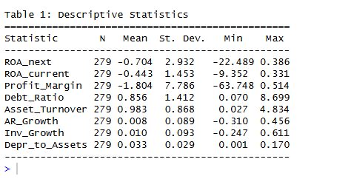
After thorough data cleaning, the dataset consists of 279 firm year observations across 182 companies from 2011 to 2013.

The mean next-year ROA is -0.704 which means that firms have lost money on average relative to their assets with an SD= 2.932. The average Profit Margin of -1.804 confirms that a large portion of firms in the sample were operating at a loss during this period. The Debt Ratio averages 0.856 tells us most firms owe more money than they own. Asset turnover of 0.983 shows that firms are generating close to $1 in revenue for every dollar of assets they hold. The remaining variables - Accounts Receivable Growth (0.008), Inventory Growth (0.010), and Depreciation to assets (0.033) are all close to zero, which is normal for these types of financial ratios. A histogram has been plotted using R for visualizing the distribution of Next year ROA.
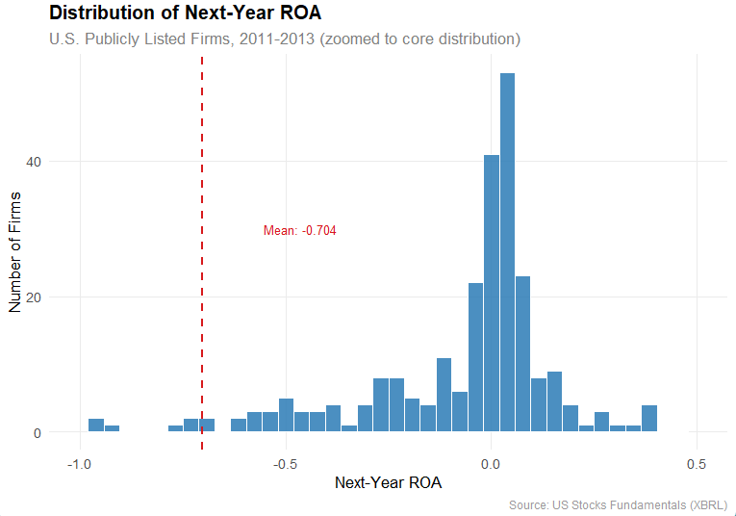

5.2 Correlation Analysis
The correlation table and matrix chart was built using R, and the financial ratios show several notable relationships between the variables.
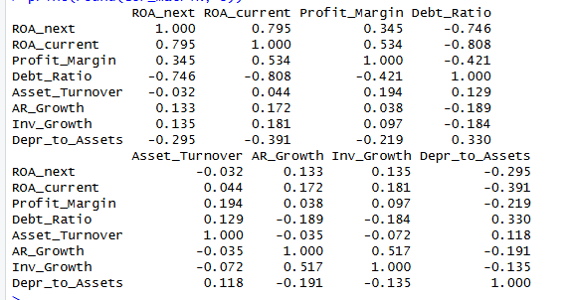
The current year ROA and next year ROA have a strongly positive correlation with 0.795, which gives us a strong signal that the firms across performing well in the current year are more likely to perform well in the next year, which proves one of our hypotheses. The Debt Ratio is negatively correlated with both current ROA (-0.808) and next-year ROA (-0.746), which means it's a predictor that firms carrying more debt tend to perform worse in both the current and following year. The Profit Margin gives us an idea that it tends to carry more predictive values since current ROA (0.534) and next-year ROA (0.345) are moderately correlated. Depreciation to assets is negatively correlated with current ROA (-0.391) and next-year ROA (-0.295), which indicates that more asset heavy firms tend to generate lower returns.
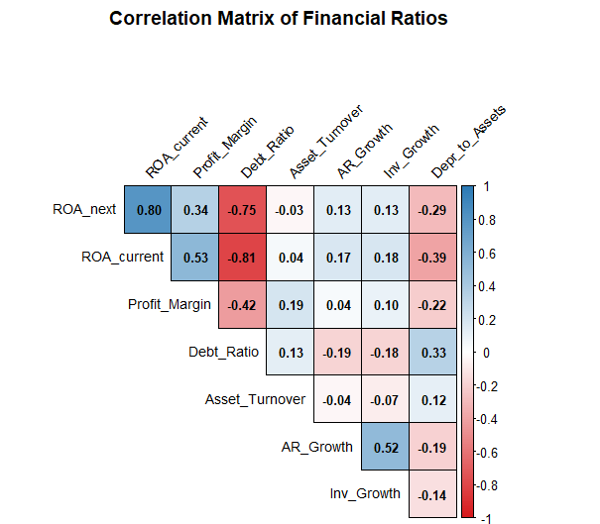
Lastly, the AR growth and Inventory growth in the correlation matrix graph show a moderate positive correlation with each other (r = 0.517), it means there is a noteworthy co-movement between how much firms expand their receivables and how much they build up their inventory in the same period. Multicollinearity testing confirmed that both variables are within acceptable levels and kept as separate predictors as they do not negatively influence the regression model.

5.3 Regression Assumption Tests
We performed 3 diagnostic tests with R regression to verify the models before interpreting the results.
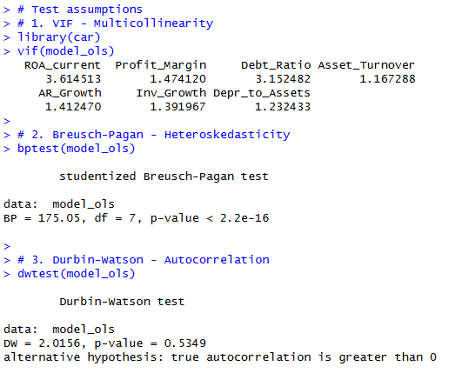
Multicollinearity (VIF): All financial predictor values are below 5, notably current ROA (3.61) and debt ratio (3.15) were the highest, meaning none of the predictors overlap too much with each other and the model results are not distorted.
Heteroskedasticity: The p value is < 0.001 and the test came back significant with a BP = 175.05, which means standard errors were applied in R to fix the prediction errors before interpreting any results.
Autocorrelation: It is also known as the Durbin Watson test, giving us a value of 2.016 with a p value of 0.535, which means firm observations are independent of each other and errors do not significantly affect one another.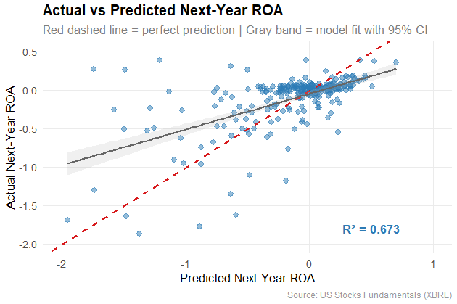
The Actual vs Predicted plot shows how well the model fits the data. Most points cluster around the regression line with an R² of 0.673, which means the model captures the general direction of next-year ROA well. Some dots are visible at extreme negative values, where the model slightly underpredicts losses for the worst performing firms.
Overall, the model passed two tests cleanly and the one issue found - Heteroskedasticity test errors were corrected before drawing any conclusions.

5.4 OLS Regression Results
We used all 7 predictors to estimate the OLS regression model to evaluate the next year ROA. The model shows that there’s 67.3% of variation in next year ROA with an Adjusted R² = 0.665, p < 0.001, and F-statistic of 79.969. It gives us an idea that the model is a strong fit for cross-sectional financial data and the three predictors are statistically significant.
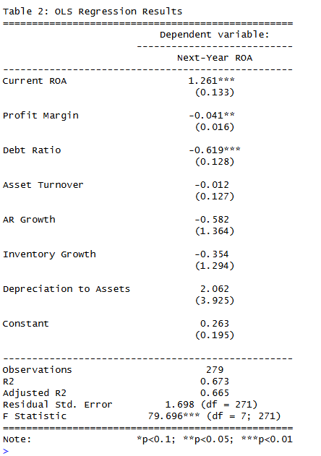
The Current ROA is at 1.261 with p < 0.01, which strongly affirms that past profitability predicts a company’s future performance. The Debt Ratio is at -0.619 with p < 0.01, it means companies with a higher debt reduces their future ROA. Profit Margin is at negative -0.041 with p < 0.05, it is likely due to the high number of loss-making firms in the US stocks dataset. Asset turnover, AR growth, inventory growth, and depreciation to assets were not statistically significant.
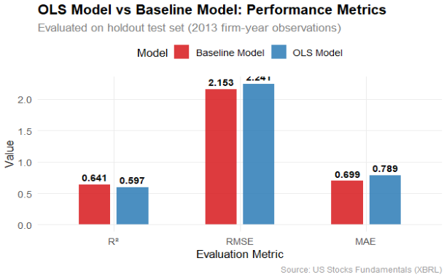
As depicted in the bar chart, the baseline model slightly outperformed the full OLS model among 3 metrics - higher R², lower RMSE, and lower MAE. This tells us, adding six extra predictors with current ROA did not significantly improve out-of-sample prediction accuracy. This is most likely because the training sample of 127 observations is too small to support a multi-variable model and it increases the risk of overfitting. However, this does not undervalue the OLS model. Since the multi-variable model did not outperform the baseline model due to limited training data, the OLS model provides greater interpretive value by identifying which specific financial factors drive future ROA and H3 was also partially supported.
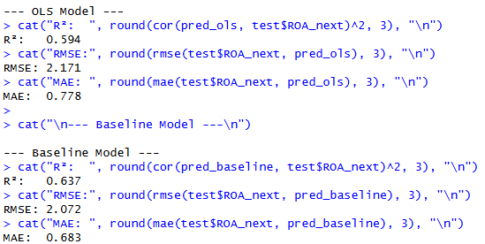

5.5 Regression Analysis by Firm Size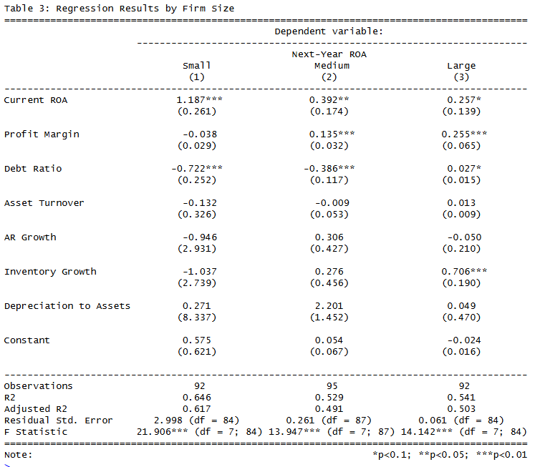
Separate regressions by firm size reveal that predictive factors shift meaningfully across groups, strongly supporting H2.
Small Firms have an R² of 0.646, Current ROA of 1.187 and p value < 0.01. Small firms have a Debt Ratio of negative -0.722 with p value < 0.01. This tells us that small firms heavily depend on current earnings for their future performance and are most sensitive to leverage.
Medium Firms have an R² of 0.529, Current ROA of 0.392 and p value < 0.05. Medium firms have a Profit Margin of 0.135 with p value < 0.01 and a Debt Ratio of negative -0.386 with p value < 0.01. This tells us that medium firms are driven by a more balanced mix of predictors where profitability starts playing a bigger role alongside leverage.
Large Firms have an R² of 0.541, Profit Margin of 0.255 and p value < 0.01 and Inventory Growth of 0.706 with p value < 0.01. Large firms have a Debt Ratio of nearly zero at 0.027 with p value < 0.1. This tells us that large firms are least sensitive to debt and are more driven by profit margins and operational efficiency, suggesting they can absorb leverage without the same negative impact on future profitability that smaller firms experience.
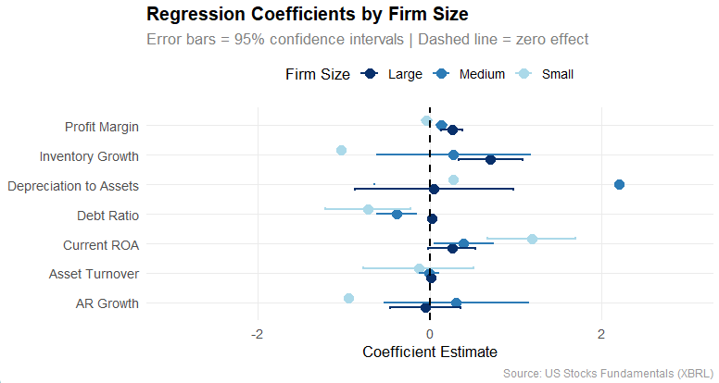
The coefficient plot visually tell us that Large firms show tighter and more precise estimates while Small firms have wider confidence intervals. It also reflects greater uncertainty in predicting future ROA for Small firms.

5.6. Summary of Hypothesis Results

Hypothesis | Result | Finding
H1 | Partially Supported | Current ROA of 1.261 and p value < 0.01 strongly confirms earnings persistence, but profit margin was unexpectedly negative, which partially contradicts with H1.
H2 | Supported | Predictive factors differ meaningfully across small, medium, and large firms, which confirms that firm sizes greatly influence which financial indicators predict next-year ROA.
H3 | Partially Supported | The multi-variable model did not outperform the baseline out-of-sample due to limited training data, but provides greater interpretive value for identifying specific financial predictors.

6. Limitations
- Missing data/reduced sample size: One limitation of this project is the amount of missing data after cleaning. In statistics a larger sample size is better because it reduces random error, makes estimates more precise, provides a smaller margin of error and makes patterns easier to detect. While cleaning theXBRL data made analysis more manageable and consistent it did result in reduction of sample size. This matters because the removed observations may have not been random. We may have removed firms that are smaller, distressed or inconsistent in their reporting, leading to a potential bias of firms with more complete and stable reporting and creating uncertainty in findings being generalized to all publicly traded firms. The final analytic dataset covers only 279 firm-year observations across 182 companies, which is relatively small for a seven-predictor regression model.
- OLS/Panel data limitations: Another limitation is the use of pooled OLS regression with panel data. Since the dataset contains company level and year level patterns a basic OLS may not fully account for differences between firms or changes over time. Because of this, results may be affected by unobservable factors and future analysis should take this into account when using a model ensuring that fixed effects or random effect methods are used.
- Regression assumption limitations: Another limitation is the regression model. If some of the financial ratios are too closely related it can be harder to figure out which predictor is driving the results. This model may also be affected by heteroskedasticity, autocorrelation, outliers and non-normal residuals. These issues do not make the model invalid but can affect accuracy of the coefficient, standard errors and significance testing. In this study heteroskedasticity was detected and corrected using robust standard errors (HC3), and Multicollinearity testing confirmed multicollinearity was within acceptable limits
- Validation limitation: Another limitation is model validation. The regression model may perform well on the dataset used to build it but may perform worse on a new data set. Stronger validation is needed to ensure it can predict next year ROA for firms beyond the sample. Future projects should include cross-validation and out of sample testing. It will help ensure that the model can be generalized across different data sets and not just explain patterns existing in our dataset. In this study the OLS model was evaluated on a 2013 holdout test set where the baseline model marginally outperformed the full model across R², RMSE, and MAE, highlighting the impact of small training sample size on out-of-sample performance.
- Reproducibility / timeline limitation: Finally, the project is limited by time and reproducibility. Since the project is subject to a course timeline there was limited time to test multiple model types and fully refine the final analysis. Future work could apply the same model to different datasets to see whether similar results are found, which would help verify the model. Additionally, the dataset covers only 2011 to 2013, a narrow window that may not capture financial dynamics across different economic cycles.

7. Conclusion
The goal of this study was to evaluate whether financial indicators derived from Kaggle’s US Stocks Fundamentals XBRL dataset could be used to predict a firm’s next year return on assets. After cleaning and structuring the dataset, regression analysis was applied to examine how current financial ratios relate to return on assets.
The results show that current return on assets is the strongest and most consistent predictor of next year return on assets, providing strong evidence of earnings persistence. Debt ratio also emerged as a significant negative factor, highlighting the role of financial risk. While additional variables like profit margin and efficiency measures were factored into the overall model, their effects were less consistent across specifications.
Furthermore, the difference across firm sizes demonstrate that the primary drivers of performance vary, and there may not be a single variable that accurately predicts return on assets across every firm, but rather should be weighed within the context of the other factors. Although the multivariable regression model did not outperform the baseline model in prediction accuracy, likely due to the limited sample size, it still provided valuable insights by identifying which financial variables were statistically meaningful and how they drive return on assets performance.
More broadly, this project demonstrated the potential of the XBRL dataset as a valuable resource for financial analysis when it is properly structured and prepared. While raw XBRL data is chaotic and difficult to use across firms, the process of cleaning, standardizing, and transforming it into a firm year dataset allows for meaningful large scale analysis that would be difficult to achieve otherwise.
The findings highlight how data driven approaches can support better decision making by helping stakeholders and analysts focus on the most relevant financial signs when evaluating firm performance. In practice this means that firms can utilize data-driven assessments focused on the future as opposed to purely descriptive analysis. Ultimately, the project reinforces the idea of predictive analytics as a framework for improving financial insight, while emphasizing the importance of the specific context for each firm.

8. Appendix

8.1 Scope Statement
Product Scope Description
This research was conducted by Group 4, composed of Seth Reyes, Adetoro Soyemi, Amara Uazim, William Adams, and Samiha Tanjeem to examine the relationship between current-year financial metrics and next-year Return on Assets (ROA). Group 4 used regression modeling to identify which financial ratios are the strongest predictors of next-year ROA.
Product Acceptance Criteria
Acceptance criteria were met by identifying the key variables for predicting next-year ROA , and can report on those predictions.
Project Deliverables
Planned, designed, and created regression models to predict next-year Return on Assets (ROA) and assumptions were cleared in this document.
Project Exclusions
Real-time data and production level deployment were not within scope.
Project Constraints
The project was done without a monetary budget and the team members were required to complete the final project report by the end of Week 12.
Project Assumptions
Group 4 worked together to finish the project according to the Professor’s guideline schedule. The work was split and shared amongst the group, and was submitted prior to the deadline.

8.2 Stakeholder Register

Stakeholder | Main Interests | Power and Influence
Dr. Lind | Evaluate project methodology, analysis quality, and final report. | High Power and influence
Group 4 | Executing the project and presenting results. | Medium Power, High Influence
ETAMU | Ensuring students are knowledgeable prior to graduation. | Medium Power, Medium influence
Potential Future Investors | Hypothetically could use findings to influence future investment decisions. | Low power and Low Influence

8.3 Business and Technical Requirements
The purpose of this document is to summarize methodology, decision points, and processes related to the project.
- For this research, we expected to find a correlation between past business performance and future business performance.
- The population for the research was the businesses within the US Stocks Fundamentals (XBRL) dataset.
The project identified key performance indicators and ratios which were used to predict next year ROA and explainable regression models (R², RMSE, MAE).
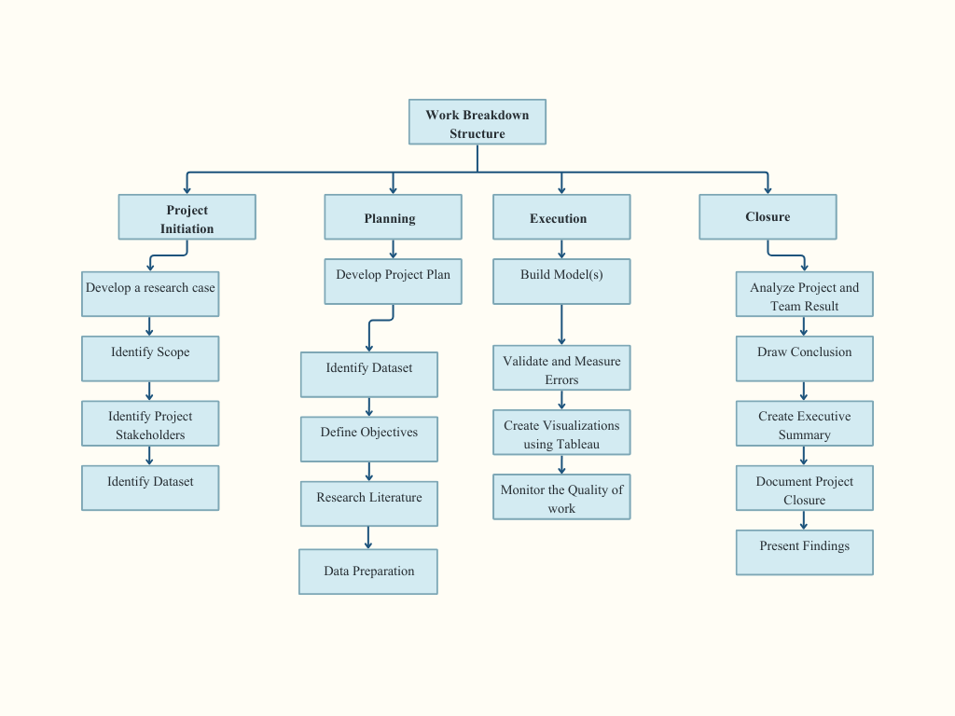

8.4 Dataset Assessment
8.4.1. Scope & Coverage
The dataset initially contained financial fundamentals for over 12,000 U.S. companies, making it highly comprehensive for market wide analysis. It included approximately 8,500 financial indicators derived from income statements, balance sheets, and cash flow statements over a five-year period using annual data. After restructuring the data, it covered 279 firm years across 182 companies from 2011-2013. This broad coverage allowed for cross industry analysis.
The dataset was strong in terms of breadth, given the large number of companies included, but weaker in terms of standardized comparisons across all firms. Dataset preview:
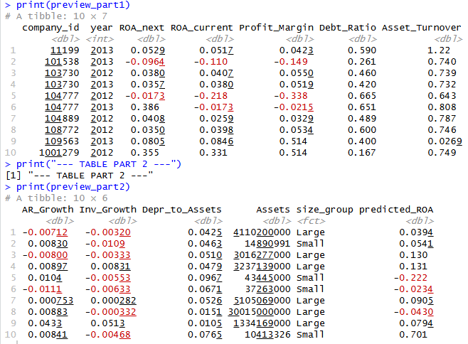
8.4.2. Financial Performance Trends
The dataset includes core financial statements that were analyzed:
- Revenue & Net Income:
  - Many companies show variability year-to-year, reflecting economic cycles and industry volatility
- Assets vs Liabilities:
  - Larger firms tend to maintain higher assets bases, but also carry significant liabilities, indicating leveraged growth strategies.
- Cash Flow Patterns:
  - Companies with strong flow tend to be more financially stable compared to those relying heavily on financing activities.
Cash low is a more reliable indicator of financial performance than net income alone.
8.4.3. Variability Across Companies
The dataset highlights major differences in company sizes and performance:
- Some firms report extremely large financial values (billions), while others are much smaller.
- There is high variance and skewness in financial metrics.
8.4.4. Dataset Structure and Challenges
The dataset structure was split into:
- Company table: basic company info (12,000 companies)
- Indicator table: Over a million rows of financial metrics across years
The challenges were identified included:
- Many missing values across indicators
- Different companies report with different metrics (XBRL flexibility)
- Requires preprocessing before analysis
8.4.5. Time-Based Insights
The dataset spans 2010-2016, allowing trend analysis over time:
- Some companies show consistent growth across years
- Others show volatility, possibly due to industry changes and economic conditions.
8.4.6. Key Analytical Opportunities
This dataset supports multiple types of analysis:
- Profitability Metrics (ROA, Asset Turnover, Profit Margins)
- Financial Health Assessment (Debt ratios, Liquidity)
- Company Comparison across industries
- Predictive Modeling (e.g., bankruptcy, growth forecasting

9. References
Barth, M. E., Cram, D. P., & Nelson, K. K. (2001). Accruals and the prediction of future cash flows. The Accounting Review, 76(1), 27–58.
Casey, R. J., & Ruch, G. W. (2024). Are earnings better than cash flows at predicting future cash flows? Evidence from apples-to-apples comparisons. Review of Accounting Studies, 29(4), 3218–3257.
Algaba, A., & Boudt, K. (2017). Generalized financial ratios to predict the equity premium. Economic Modelling, 66, 244–257.
Soyode, A., & Bande, B. O. (2016). Predicting corporate financial troubles with accounting ratios: Evidence from Nigeria. Journal of Financial Management and Analysis, 29(1), 38–47.
Lev, B., & Thiagarajan, S. R. (1993). Fundamental information analysis. Journal of Accounting Research, 31(2), 190–215.
Pirveli, E. (2020). Earnings persistence and predictability within the emerging economy of Georgia. Journal of Financial Reporting & Accounting, 18(3), 563–589.
Farshadfar, S., & Monem, R. (2013). Further evidence on the usefulness of direct method cash flow components for forecasting future cash flows. The International Journal of Accounting, 48(1), 111–133.
Farshadfar, S., Ng, C., & Brimble, M. (2008). The relative ability of earnings and cash flow data in forecasting future cash flows: Some Australian evidence. Pacific Accounting Review, 20(3), 254–268.
Konchitchki, Y., & Patatoukas, P. N. (2014). Taking the pulse of the real economy using financial statement analysis: Implications for macro forecasting and stock valuation. The Accounting Review, 89(2), 669–694.
Bloomberglaw.com. (2025). https://www.bloomberglaw.com/external/document/X6E7BDHS000000/capital-markets-overview-xbrl-rules

